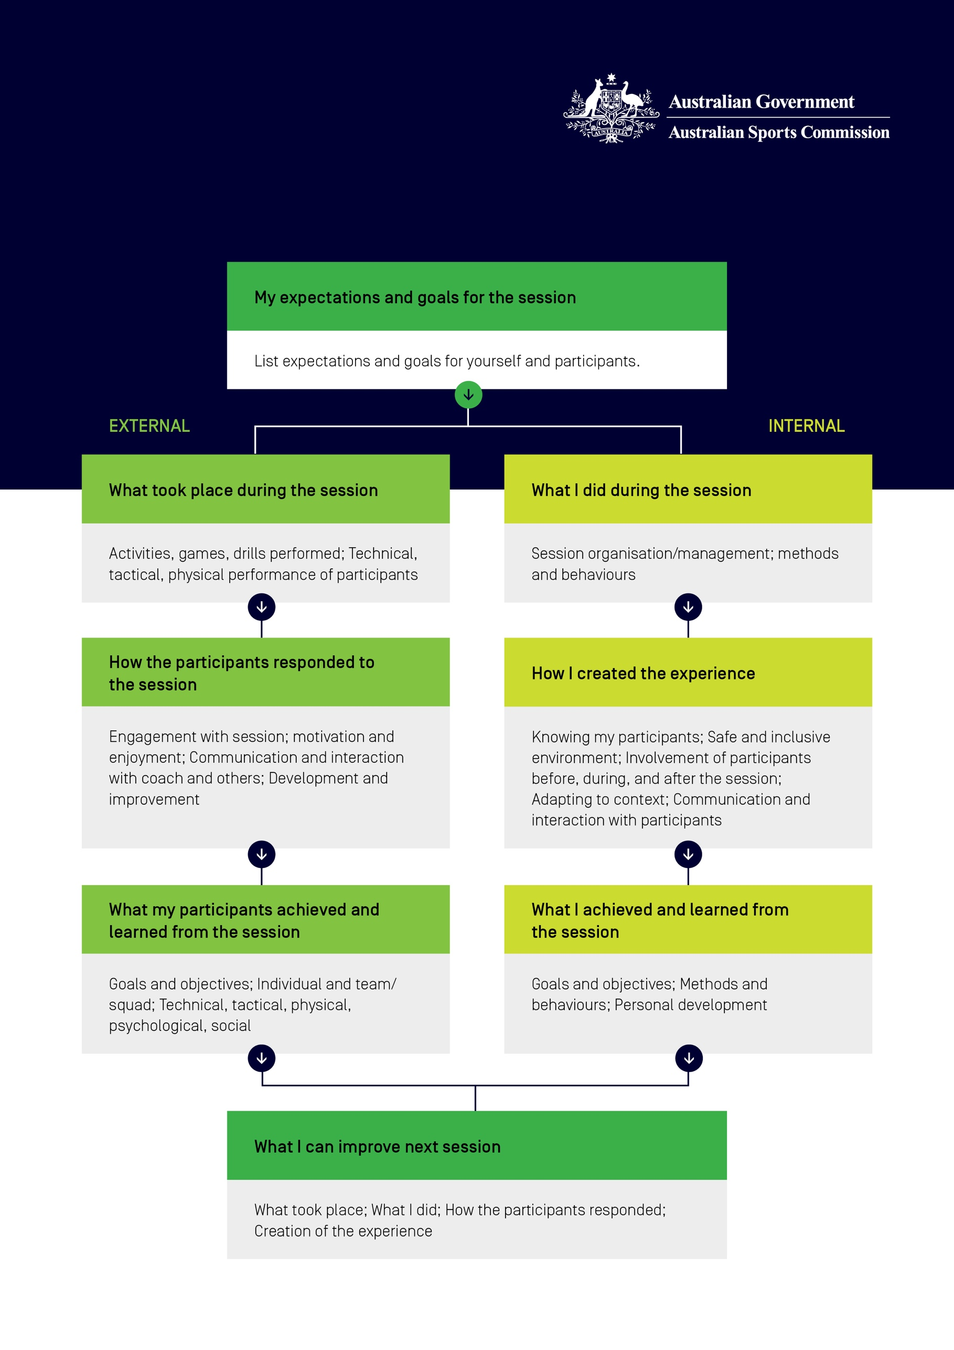
Reflection Template Instructions

Document your reflections

My expectations and goals for the session

What took place during the session

How the participants responded to the session

What my participants achieved and learned from the session

What I did during the session

How I created the experience

What I achieved and learned from the session

What I can improve next session

