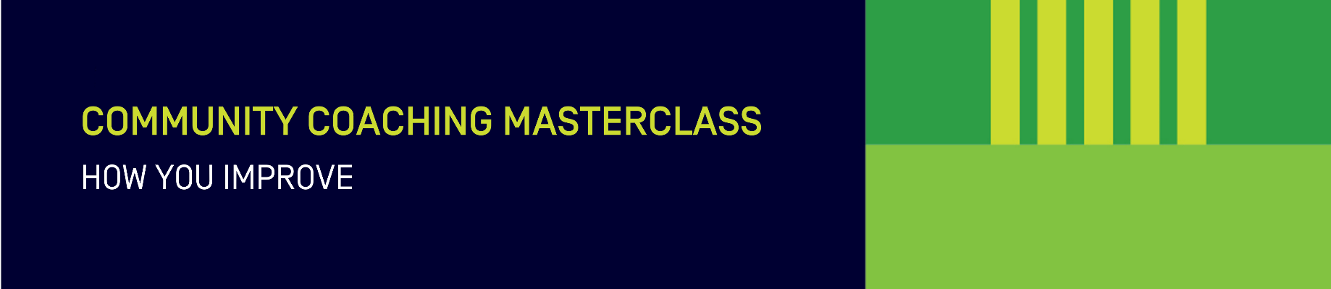

Reflection template

What happened?
Give a brief description of what took place during the session.

What do I already know?
Consider what happened and how this relates to your own skills and understanding.

What does it mean?
Try to explain what happened.

What will I do next time?
Make a conclusion about what happened, recommend possible changes and improvements and suggest how this can be applied in future to improve on what happened.

Adapted from Moon (2013). A handbook of reflective and experiential learning: Theory and practice. Routledge.

